Margherita Ruoppolo

CURRICULUM VITAE

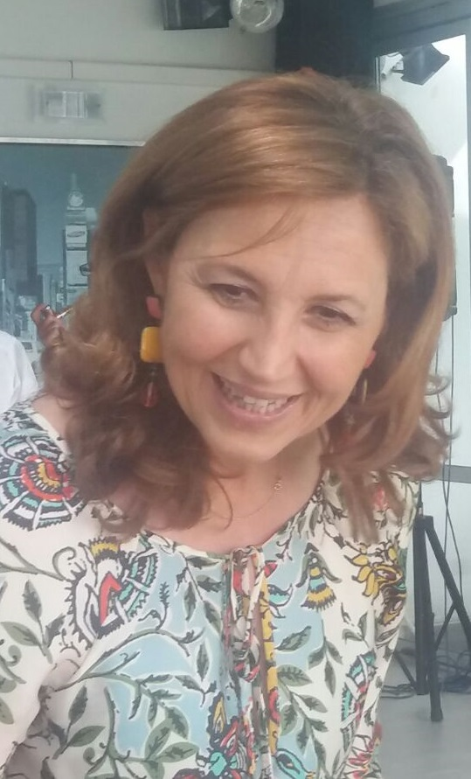
Personal information
Date and place of birth: 8 May 1966, Naples, Italy
Marital status: Married (two children)

e-mail: margherita.ruoppolo@unina.it
ORCID ID: https://orcid.org/0000-0002-7364-0602
Scopus ID: 56264192200

Present Position:
Full Professor of Biochemistry, Department of Molecular Medicine and Medical Biotechnology, School of Medicine, Via Pansini 5, 80131 Naples, Italy, e-mail: margherita.ruoppolo@unina.it

Education
April 1990 Obtained a five year degree in Chemistry (Organic and Biological Chemistry) with summa cum laude. The work on the" Characterisation of disulphide bridges in proteins using FAB Mass Spectrometry: a new approach for studying protein folding" for the thesis was performed at the University of Naples "Federico II".

November 1990 Awarded the qualification to practice as a professional Chemist.

July 1997 PhD. in Chemical Sciences with a thesis on "Folding of proteins" University of Naples "Federico II".

Professional experience
  - CNR fellow at the Servizio di Spettrometria di Massa, CNR- University of Naples "Federico II" to carry out research on the identification of post-translational modification in proteins.

May 1996-October 2001 Research Assistant of Biochemistry at the Department of Chemistry, University of Salerno. A research group on protein chemistry was organised from scratch in a typical Organic Chemistry Department to provide undergraduate students with a support system to begin research work in this field at the University of Salerno. A total of five undergraduates were accepted from 1996 to2001, trained and tutored

November 2001- October 2007 Associate Professor of Biochemistry at Department of Biochemistry and Medical Biotechnology , University of Naples, Federico II.

2007-to date - Full Professor of Biochemistry at Department of Biochemistry and Medical Biotechnology, University of Naples, Federico II.

November 2003 to date - Head of Laboratory for Screening of inborn errors of metabolism, Dipartimento Assistenziale Integrato di Medicina di Laboratorio, Azienda Universitaria Policlinico, University of Naples, Federico II

Research activity in foreign laboratories
1989 Biological Laboratory, University of Kent, Canterbury

1991 Laboratoire de Spectrometrie de Masse Bio-Organique, University of Strasbourg

  - Biological Laboratory, University of Kent, Canterbury

1998 Unité de Biochimie, Institut Pasteur, Paris, France (Prof. M. Goldberg)

Research Overview
The scientific activity of Margherita Ruoppolo has been mainly devoted to the structural characterization of proteins and metabolites. These studies were carried out developing integrated strategies based on biochemical methodologies combined with biomolecular mass spectrometric procedures. She started studying the mechanism of the folding process of proteins paying particular attention to the structural characterization of intermediates accumulating during the oxidative folding of disulphide-containing proteins. She then focused her research on the identification of individual proteins in complex mixtures by proteomic approaches using fractionation of protein by 1D/2D gel electrophoresis and identification of protein bands by enzymatic hydrolysis, mass spectrometry and database search. These methodologies were applied in biomedical projects in order to find the differences between normal and pathological cellular conditions.
Finally, she focused on the study of inborn errors of metabolism using biochemical and genetic integrated methodologies.
The research activity described above was carried out in collaboration with CEA-Saclay, France; University of Halle, Germany; University of Kent, United Kingdom; University of Munich, Germany; University of Oulu, Finland; Karolinska Institute, Sweden; Institut Pasteur, Paris, France; University of Wisconsin, USA; Mayo Clinic, Rochester Minnesota, USA; Organic Acid Research Section, Genetics and Molecular Biology Branch, NIH, USA.

Complete list of published work in PubMed:
https://www.ncbi.nlm.nih.gov/pubmed/?term=ruoppolo

Bibliometric data (Scopus, May 2025)
- Number of publications: 132
- H index: 32
- Total number of citations: 3307

Academic Honours and Awards
February 1991 "Federchimica - per un futuro intelligente" prize of Italian Confederation of Chemical Industries.

May 1991 1990 “Guglielmo Laonigro” prize of the Italian Chemical Society.

March 1993 Accademia Nazionale dei Lincei-Royal Society fellowship.

January 1994 International Human Frontier Science Program Organization (HFSPO) fellowship.

April 1994 EMBO (European Molecular Biology Organization) fellowship.

2018 Participation in the second Scientific Evaluation Meeting of E-Rare Joint Transnational Call JTC2018

Invited Referee
Frequently referees manuscripts for international journals such as Biochemistry, Protein Sciences, Journal of inherited metabolic disease, International Journal of Molecular Sciences, Scientific Report; Associated Editor Helyion
Guest Editor of Special Issue
"Molecular Research on Inherited Disorders"

Membership
Member of the Italian Chemical Society, Mass Spectrometry Division: between 1993-1996 she was a member of the Board of Directors of the Mass Spectrometry Division.
Member of the Italian Biochemical Society.
Member of the Italian Society for the study of inborn errors of metabolism.
Vice-president of the Italian proteomic association,

Grants as principal investigator
PRIN 2002: Genomic and post-genomic analisis of normal and pathological eritropoiesis
PRIN 2004: Molecular characterization of eritropoiesis: post-genomic and functional analysis of protein expression profile
PRIN 2006: Normal and pathological eritropoiesis; molecolar charactrization by high throughput technologies
AIFA 2006: Multicentre study of the efficacy and tolerability of tetrahydrobiopterin in a paediatric population affected by phenylketonuria
2017 funding for the implementation of extended neonatal screening of inborn errors of metabolism
2018 funding for the implementation of extended neonatal screening of inborn errors of metabolism
PRIN 2017: Triggering neuroprotective pathways to prevent neurodegeneration: role of estrogen receptor beta/neuroglobin signaling in Huntington disease

Invited lecturer
- Partly folded intermediates in three-fingered toxin folding
23rd IUPAC-2002 International Symposium on the Chemistry of Natural Products 28 Luglio-2 Agosto 2002, Firenze
- Proteomics identification of acyl-acceptor and acyl-donor substrates for transglutaminase in a human intestinal epithelial cell line
Congresso SIB 2003 15-18 Settembre 2003, Ferrara
- Erythroid membrane proteomic
Proteine 2004, 20-22 Maggio 2004, Viterbo, Italy
- Post-translational modifications in the age of proteomics: functional map of transglutaminase substrates
Chemistry and Biology: The transition between the two centuries” Accademia Nazionale dei Lincei 8-10 November 2004, Roma
- Differential proteomics in molecular medicine.
Clinbio 2005 11-12 November 2005 Napoli
- Metabolomics: diagnostic applications
52° Congresso nazionale SIB 26-28 September 2007, Riccione
- Exploring inborn errors of metabolism through metabolomics
57th national meeting of the Italian society of biochemistry and molecular biology 18-20 September 2013 Ferrara
- Integration of metabolomics and proteomics in exploring rare diseases
International Conference on "The Kidney in Genetic and RareDisease", Naples, October 27th – 29th, 2016
- Altered intracellular pathways in inherited disorders of vitamin B12 metabolism Protein 2018, Verona, Italy 28-30 May 2018
- The OMIC landscape of organic acidemias 61° SIB MEETING Virtual Edition 23-24 September 2021
11 Metabolomics in gender medicine XX1st SIMDO national congress October 2022, Taormina, Italy
12. Metabolomics and lipidomics from a gender perspective SEX/GENDER MEDICINE Sex/gender differences in diabetic disease ... and not only Olbia, 21-22 April 2023
13 Omics platforms for the study of mitochondrial dysfunctions RAS-MAPK pathway pathologies: the importance of the multidisciplinary network 19-20 May 2023, Salerno, Italy
14 Metabolomics of diabetes XXI SIMDO national congress October 2023, Naples, Italy
15. Extended neonatal screening for metabolic diseases: the role of the laboratory, goals achieved and perspectives, Neonatal Screening in the Campania Region, Aula Magna University of Naples “Federico II” 11 December 2024
16 Neonatal screening: reality and perspectives, neonatology meeting 16 May 2025, Paola, Italy

June 2025



